KWAME NKRUMAH UNIVERSITY OF SCIENCE AND TECHNOLOGY

COLLEGE OF ENGINEERING

DEPARTMENT OF MECHANICAL AND CHEMICAL ENGINEERING

ME 396 MECHANICAL ENGINEERING LABORATORY IV.

GROUP P



**A REPORT ON DEFLECTION OF BEAMS AND CANTILEVERS; CIRCULAR BENDING**

***LAB TECHNICIAN:*** Mr. Joseph Amuzu

***LECTURER:*** DR. Y.A.K FIAGBE

**GROUP MEMBERS**

|  |  |
| --- | --- |
| **NAMES** | **INDEX NUMBERS** |
| AGBOADO JOHNNY EDEM | 9366817 |
| EGWIM-NWAGBARA FRANKLIN | 9380017 |
| YAHYA PAUL KWAME | 9379617 |
| FIANNAA CLIFFORD | 9373817 |
| AZIZ NAFIW | 9371117 |
| FAMIYEH EBENEZER | 9373717 |
| ASANTE-FOSU MAAME AFIA | 9370317 |
| AZAMETSI-MENSAH JOSHUA | 9371017 |
| AFFUL GABRIEL NANA KOJO AHINSAN | 9366217 |

**INTRODUCTION**

In this experiment, we induced a moment on a beam by applying loads to the simply supported beam and thus producing circular bending on the beam. This helped us to establish an important relationship, one of the accurate methods for measuring the Young’s modulus.

**AIM OF THE EXPERIMENT**

The experiment was to determine the Young’s modulus of the beam.

**THEORY**

In this experiment we used the following formulas:

$$\frac{M}{I}=\frac{E}{R}……(1)$$

Where;

**M**=Applied moment (Nm)

**R**=Radius of curvature(m)

**E**=Young’s modulus for cantilever material (Nm-2)

**I**=second moment of area of the cantilever(m4)

Where;

**R**=radius of curvature (m)

**C**=chord=0.4 (m)

**h**=height of cord (m)

$$I=\frac{{bd}^{3}}{12}……..(3)$$

Where;

**I**=second moment of area of the cantilever(m4)

**b**= width (mm)

**d**= depth(mm)

=6.08405 m4

=1.33m4

m4

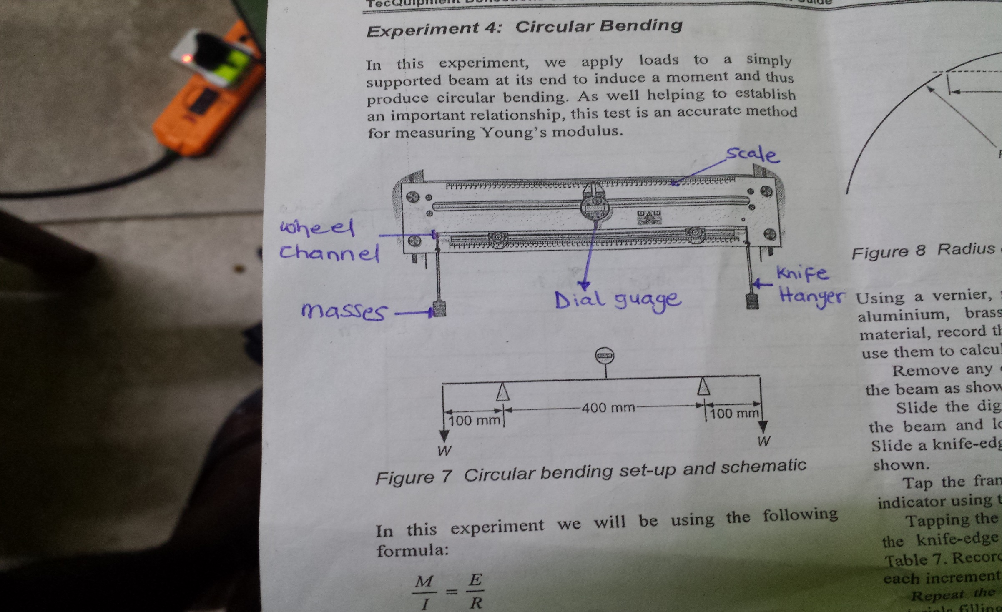

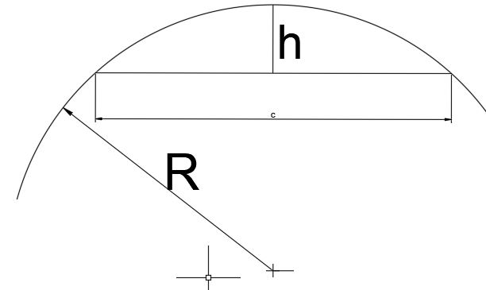

**APPARATUS**

* Vernier calipers
* A meter rule
* Dial gauge
* Test rods (brass, steel, aluminum)

**PROCEDURE**

1. Using a Vernier, measure the width and depth of the *aluminum, brass* and *steel* test beams. For each material, record the values next to the results tables and use them to calculate the *second moment of area, I.*
2. Remove any clamps from the backboard and set up the beam horizontally
3. Slide the digital dial indicator into position on the beam and lock it using the thumbnut at the rear
4. Slide the knife-edge hanger on to each end of the beam
5. Tap the frame lightly and zero the digital dial test indicator using the origin button.
6. Tapping the frame lightly each time, apply masses to the knife-edge hangers in increment of *100g*
7. Record the digital dial test indicator reading for each increment of mass
8. Repeat the procedure for the other two specimens

**TABLES OF RESULTS**

|  |  |  |  |  |  |  |  |  |  |
| --- | --- | --- | --- | --- | --- | --- | --- | --- | --- |
| **Material:** Brass | | **E value**: 105 G Nm-2 | | **Width, b**:20.88 mm | | **Depth, d**: 3.27 mm | | | I: 6.08405x m4 |
| Mass at each end (g) | Deflection(mm) | | Applied moment (Nm) | | Radius of curvature (m) | | 1/R | $$\frac{M}{I}(x{10}^{9})$$ | |
| 0 | 0.00 | | 0.0000 | | 0.00 | | 0.000 | 0 | |
| 100 | 0.40 | | 0.1278 | | 50.00 | | 0.020 | 2.100 | |
| 200 | 0.52 | | 0.1661 | | 38.46 | | 0.026 | 2.730 | |
| 300 | 1.14 | | 0.3642 | | 17.54 | | 0.057 | 5.986 | |
| 400 | 1.53 | | 0.4888 | | 13.07 | | 0.077 | 8.034 | |
| 500 | 1.94 | | 0.6196 | | 10.31 | | 0.097 | 10.184 | |

|  |  |  |  |  |  |  |  |  |  |
| --- | --- | --- | --- | --- | --- | --- | --- | --- | --- |
| **Material:** Aluminum | | **E value**:69G Nm-2 | | **Width, b**: 20.85 mm | | **Depth, d**: 4.25 mm | | | **I**: 1.33x m4 |
| Mass at each end (g) | Deflection(mm) | | Applied moment (Nm) | | Radius of curvature (m) | | 1/R | $$\frac{M}{I}(x{10}^{9})$$ | | |
| 0 | 0.20 | | 0.092 | | 100.000 | | 0.0100 | 0.6855 | | |
| 100 | 0.69 | | 0.317 | | 28.986 | | 0.0345 | 2.3805 | | |
| 200 | 1.30 | | 0.597 | | 15.385 | | 0.0650 | 4.4850 | | |
| 300 | 1.85 | | 0.849 | | 10.812 | | 0.0925 | 6.3820 | | |
| 400 | 1.96 | | 0.899 | | 10.204 | | 0.0980 | 6.7617 | | |
| 500 | 1.97 | | 0.904 | | 10.152 | | 0.0985 | 6.7962 | | |

|  |  |  |  |  |  |  |  |  |  |
| --- | --- | --- | --- | --- | --- | --- | --- | --- | --- |
| **Material:** Steel | | **E value**: 207G Nm-2 | | **Width, b**:18.91 mm | | **Depth,d**: 3.31 mm | | | **I**: 5.72x m4 |
| Mass at each end (g) | Deflection(mm) | | Applied moment (Nm) | | Radius of curvature (m) | | 1/R | $$\frac{M}{I}(x{10}^{9})$$ | | |
| 0 | 0.08 | | 0.0513 | | 250.00 | | 0.0040 | 0.8283 | | |
| 100 | 0.19 | | 0.1218 | | 105.2633 | | 0.0095 | 1.9666 | | |
| 200 | 0.40 | | 0.2564 | | 50.0002 | | 0.0199 | 4.1400 | | |
| 300 | 0.61 | | 0.3910 | | 32.7872 | | 0.0304 | 6.3132 | | |
| 400 | 0.78 | | 0.500 | | 25.6414 | | 0.0390 | 8.0731 | | |
| 500 | 0.88 | | 0.5641 | | 22.7277 | | 0.0440 | 9.1078 | | |

**GRAPHS**

**CONCLUSION**

1. From $\frac{M}{I}=\frac{E}{R}$

y=m(x)+c

Therefore, it can be concluded that a graph of ***M/I*** against ***1/R*** gives a slope of ***E (the young modulus of the beam).***

1. From the tables and graphs, it can be concluded that brass deflects(bends) more than aluminum and steel

**REFERENCES**

1. TecQuipment Deflection of beams and cantilever: student guide

2. R._C._Hibbeler-Mechanics_of_Materials,_8th_Edition__-Pearson_Prentice_Hall(2010)